**Working in Cold Weather – General Safety**

Prolonged exposure to freezing temperatures can result in injuries as serious as frostbite and hypothermia. Cold weather takes away body heat. Too much heat loss can cause the inner body temperature to fall to dangerously low levels causing hypothermia and even death. About 700 deaths a year are attributed to hypothermia, when the body’s internal temperature drops below 95° F. In addition:

* 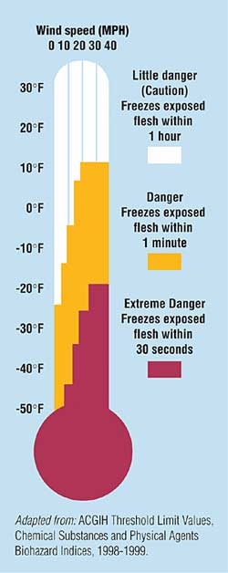Exposed body parts may freeze in extreme cold weather (e.g. frostbite).
* Cold weather can aggravate existing medical conditions such as rheumatism and arthritis.
* Cold weather affects dexterity, mental skills, and coordination.
* Prolonged exposure to even moderately cold weather can cause injuries.
* Working in coldness increases the risk of musculoskeletal injuries such as back strain.

Consider the following strategies to reduce the risk of cold injuries to workers:

* ***Wearing the proper clothes*** may be the most significant precaution to reducing cold stress. Wearing appropriate clothes for cold weather involves using three layers of clothing. Also use layering to protect the head, hands, and feet.
* ***Drink plenty of fluids***, preferably warm, sweet beverages. Thirst is suppressed in a cold environment and dehydration may occur when fluid intake is reduced.
* ***Increase caloric intake*** when working in cold environments. Workers in cold environments expend more heat and so require 10-15 percent more calories.
* ***Include Work - Warming Schedule*** should be used to provide periodic times for warm-up breaks. Additional breaks should be provided as the wind velocity increases and/or the temperature drops.
* ***Avoid taking certain drugs*** such as alcohol, nicotine, caffeine, and medication that inhibit the body's response to cold or impairs judgment *Shield work areas from drafty or windy conditions.* Provide a heated shelter for workers with prolonged exposure to equivalent wind-chill temperatures of 20° Fahrenheit or less.
* ***Select the warmest hours of the day*** when braving the cold. Minimize activities that reduce circulation.
* ***Educate employees*** on symptoms of cold-related stresses. They include heavy or uncontrolled shivering, uncomfortable coldness, waxy appearance of skin on extremities, severe fatigue, drowsiness, and/or euphoria.
* ***Use the buddy system****.* Always work in pairs when working in extreme weather conditions so partners can monitor one another and obtain help quickly in an emergency. Injuries due to cold stress can develop slowly and unobtrusively. The symptoms may go undetected until a worker’s health or life is in danger.

**Stay alert for the signs of cold-weather injuries in yourself and your co-workers.**

**Notify WHO if you suspect a dangerous condition.**

Additional points / comments to be made:

1. _______________________________________________________________________________________

_______________________________________________________________________________________

_______________________________________________________________________________________

1. _______________________________________________________________________________________

_______________________________________________________________________________________

_______________________________________________________________________________________

1. _______________________________________________________________________________________

_______________________________________________________________________________________

_______________________________________________________________________________________

Follow-up actions:

1. _______________________________________________________________________________________

_______________________________________________________________________________________

_______________________________________________________________________________________

1. _______________________________________________________________________________________

_______________________________________________________________________________________

_______________________________________________________________________________________

1. _______________________________________________________________________________________

_______________________________________________________________________________________

_______________________________________________________________________________________