This model program is intended for general information purposes only. It should not be construed as legal advice or legal opinion regarding any specific or factual situation. Always follow your organization’s policies and procedures as presented by your manager or supervisor.

ROADWAY SAFETY MODEL POLICY
Purpose:
The purpose of this document is to provide uniform operational guidelines to ensure safe operations by emergency responders dispatched to incidents on local roadways and highways. These operational guidelines are based on the Manual on Uniform Traffic Control Devices (MUTCD), Chapter 6I and the New Jersey Highway Incident Traffic Safety Guidelines for Emergency Responders. The guidelines in this document are general since they cannot cover all incidents or unique site-specific conditions. This document is not intended to be a substitute for training, technical knowledge, experience, situational awareness, and effective judgment.
Scope and Responsibilities:

Definitions:
Advance Warning: devices and procedures that advise approaching motorists to transition from normal driving status to temporary emergency traffic control measures ahead of them.
Blocker Vehicle: the initial on-scene emergency vehicle, preferably a fire apparatus, positioned on an angle to the lanes of traffic creating a physical barrier between upstream traffic and the work area. This includes using the vehicle to “block to the left” or “block to the right”.
Buffer Zone: the empty, unoccupied space or distance between emergency responders and vehicles in the incident space and moving traffic.
Downstream: the area past the incident in the direction of normal traffic flow as it travels away from the incident space.
Emergency Responder: Fire, Police, EMS and any other personnel responding to assist at an emergency scene.
Incident: any non-recurring event that causes a reduction of roadway capacity due to motor vehicle crashes, vehicle fires, natural disaster, or other unplanned event that affects or impedes the normal flow of traffic.
Incident Space: the area that includes the incident, and the necessary space around the incident required to manage the event, including vehicles and personnel.
Limited Access Highway: refers to the following roads: New Jersey Turnpike, Garden State Parkway, Atlantic City Expressway, I-76, I-78, I-80, I-95, I-195, I-280, I-287, I-295, and I-676.
Ramps: “Off-Ramp” will be used to describe a lane(s) which leads from the highway to another roadway. The term “On-Ramp” will be used to describe a lane(s) which leads from another roadway onto the highway.
Shadow Vehicle: the second due fire apparatus or other emergency responder vehicle, which positions upstream of the blocker vehicle at an angle, to create the beginning of the buffer zone.
Taper: the action of merging several lanes of traffic into fewer lanes, utilizing traffic control devices. This action begins upstream of the shadow vehicle.
Temporary Incident Control Zone: this zone extends from the first warning device to an area where the moving traffic returns to original traffic patterns and is clear of the incident. Consideration should be given to include the area which is part of the police investigation.
Transition Zone: the area/lane of roadway where approaching motorists change their speed and position to comply with the traffic control measures established at an incident scene.
Upstream: the area prior to the incident in the direction of normal traffic flow as the vehicles approach the temporary incident control zone.
Emergency Response Procedures
Incident Command:
The first arriving emergency responder will establish command of the incident and remain in control until command is transferred or the incident is stabilized and terminated.
For incidents involving multiple roadway emergency response agencies, a Unified Command structure should be implemented. Under a Unified Command, all responding agencies will cooperate and work together. Responding agencies will make decisions based on their experience and expertise in their respective fields to contribute to the successful conclusion of the incident. Any decisions made will be communicated to the other agency representatives to ensure coordination of efforts.
For limited access roadways and other state roads, when the NJ State Police arrive on an established scene, the trooper shall interface with the Incident Commander (or Unified Command if established) for an incident briefing and transfer of command if appropriate. The State Police have statutory authority over all incidents that occur on state highways and shall have final decision in all traffic control matters. The senior trooper on the scene is the Incident Commander.
Required Equipment:
In compliance with the MUTCD and fire service best practices, fire apparatus responding to incidents on highways and main roadways shall be equipped with:
- An ANSI Class 2 or 3 high-visibility safety vests for each responding personnel is required
- A minimum of six (6) NJDOT-approved retro-reflective orange or pink traffic cones
- A minimum of one (1) case of traffic flares or strobes
- A lighted arrow stick or sign board.
- A minimum compliment of basic first aid equipment and supplies
- A 48” x 48” retro-reflective pink sign stating: “Emergency Scene Ahead”
Incident Response:
Response to limited access highway and main roadway incidents should be made by the agency that has the safest and most efficient access to the incident. This may require agreements to be executed so insert name of agency can cover incidents that are in another municipality or geographical area.
Consideration should be given to using mutual aid to cover the opposite direction of a limited access highway. Mutual aid should be considered to share and provide an adequate response and adequate resources.
Once the location and scope of the incident are determined, only essential vehicles should be committed to respond out onto the roadway. All other apparatus should be returned or staged off the roadway in an uncommitted location.
Only official vehicles will be permitted on the roadway. Under no circumstances will personal vehicles respond to incidents on any limited access highways.
A sufficient crew of emergency responders is recommended for units responding to incidents on the roadway to limit the number of apparatus on scene.
Responding units will be assigned responsibility for a specific area of the roadway and may be directed to enter the roadway via a designated ramp or connecting roadway. Absent extenuating circumstances or specific orders to the contrary, companies will utilize their assigned entry point whenever responding to incidents.
Full size fire apparatus should utilize normal entrances and exits to reverse their direction of travel. Use of the median or paved U-Turns should be reserved for life threatening emergencies and extenuating circumstances.
As a last resort, it may be necessary for emergency vehicles to travel against the normal traffic flow to access an incident scene. NO units or vehicles will employ this maneuver unless they receive specific approval from the Incident Commander. Once approval is received, the emergency vehicle shall proceed with extreme caution utilizing the shoulder portion of the roadway if possible.
Arrival on Scene:
Standard practice will be to position the initial arriving emergency response vehicle in such a manner that best protects the incident space and passing motorists by creating a buffer zone. Consideration should be given to traffic flow and to providing an avenue for additional resources to access the incident space. The initially positioned vehicle shall be known as the blocker vehicle. (See illustrations in Appendix A1 & A2)
When possible, crew members should enter/exit their units on the side opposite the traffic flow. Emergency responders should always check for approaching traffic before exiting their vehicle.
The magnitude of the incident should be estimated within the first fifteen (15) minutes of arrival using the criteria set below:
- Minor – 30 minutes or less
- Intermediate – 30 minutes to 2 hours (contact Highway Agency)
- Major – more than 2 hours (contact Highway Agency)
All incidents should be updated every 15-30 minutes.
Emergency responders should always be aware of their visibility to oncoming traffic and take measures to move the traffic incident as far off the traveled roadway as possible or to provide for appropriate advance warning.
Emergency vehicles should be safe-positioned in such a manner as to optimize traffic flow through the incident scene. All subsequent arriving emergency vehicles should be positioned as to not interfere with the established temporary traffic flow.
EMS units should routinely be positioned downstream of the incident within the incident space.
If a second fire apparatus responds to the scene as a shadow vehicle, it should safely position at least 50 feet upstream of the blocker vehicle to help ensure an adequate buffer zone. The crew in the shadow vehicle shall abandon the vehicle and report to the incident space. The shadow vehicle assumes a fend-off position to deflect any high-speed impact that would otherwise crash into the incident space.
Unit operators shall cancel any warning lights which impair the vision of approaching traffic (i.e., headlights, spotlights, clear warning lights).
Position emergency vehicles on the same side of the roadway as the incident.
Traffic Control:
Emergency responders shall control oncoming traffic prior to turning their attention to the incident. Understanding that there is no absolute means to protect emergency responders at the scene of an incident on a limited access highway or main roadway, responders are urged to constantly keep in mind the “three guiding principles” when operating in or near moving traffic. Recognizing these principles will increase the margin of safety. The three guiding principles are:
- Provide Advance Warning - use traffic control devices such as signs, other emergency vehicles, or any other appropriate device that will warn or direct motorists away from an approaching incident.

- Protect the Scene - position vehicles and traffic control devices in such a way that allows for adequate space between the point where the traffic is diverted and the actual incident space. Fire apparatus should position in a manner that best protects the incident space. Such positioning affords protection to responders from the hazards of working in or near motor vehicle traffic.

- Be Visible - All responders operating at the incident on a roadway with moving traffic shall wear highly visible, highly reflective garments to increase the ability of motorists to see the emergency responders during day and night operations.
Traffic control is primarily the responsibility of the State Police, local police, transportation, or highway authorities. If the above agencies are not present, it is the responsibility of initial responders to establish a safe incident space. Traffic cones, flares, and/or emergency vehicles may be used for this purpose until appropriate equipment becomes available.
Scene conditions may necessitate the closure of the lane next to the affected lane, commonly referred to as a “buffer lane”, to provide an additional margin of safety for emergency workers, motorists, or any other unforeseen circumstances which would expose emergency workers to increased risk from passing traffic.
Placement of traffic control devices should be utilized with consideration given to drivers’ reaction time and visual obstructions. The advance warning may need to be extended upstream when factors such as topography, time of day, and weather are present and therefore increase the potential for secondary crashes.
Responders should face traffic at all times when placing and retrieving traffic control devices. Placement of cones shall begin at the corner of the blocker or shadow vehicle, while moving upstream, tapering at an angle.
An “Emergency Scene Ahead” retro-reflective pink sign should be deployed upstream of all apparatus and cones on the shoulder as per MUTCD guidelines. This shall include all types of roadway incidents with an expected duration of more than 30 minutes.
Traffic should not be allowed to pass the incident space on both sides of emergency responders unless approved by the Incident Commander. Traffic should be diverted to the left or the right of the scene.
The closure of any part of the traveled portion of the roadway must first be approved by the Incident Commander.
If state or local police arrive on scene and determine that a previously closed lane must be opened to traffic, police will order lanes reopened in consultation with the fire & EMS personnel at the scene. A reasonable amount of time will be afforded for responders to move to a safe area before the lane is opened.
If the senior fire or EMS officer does not feel adequate safety measures are in place, they should direct their personnel to a safe area until the situation is resolved with the Incident Commander at the scene.
The closing of additional lanes not affected by the incident, to include on and off ramps, shall require the approval of the State Police, local police, transportation, and highway authorities.
When communicating with other personnel responding to an incident, it is important to note the exact location of the incident and the most efficient route to access the incident.
For purposes of uniformity, traffic lanes shall be considered from the approaching motorist’s direction of travel and shall be designated as follows:
- Three lanes in each direction: Left Lane, Center Lane, Right Lane.
- Four lanes in each direction: Left Lane, Left Center Lane, Right Center Lane, Right Lane
- Five lanes in each direction: Left Lane, Left Center Lane, Center Lane, Right Center Lane, Right Lane.
- Shoulders will be designated as Left Shoulder or Right Shoulder.
General Operations:
All responders within the right-of-way of the roadway who are exposed to traffic shall wear Class II safety vests. For fire department members, full PPE (coat, pants, helmet) should be worn. Class II vests shall be worn over the fire coat for increased visibility and must be worn when the coat is removed with the exception of emergency responders who are potentially exposed to heat, flame, or hazardous materials.
Responders should be acutely aware of traffic at all times when on the scene.
Responders shall never operate in a live traffic lane. Crossing a live traffic lane should be done with extreme caution and should be avoided when possible.
Hose lines/equipment should be deployed from the apparatus from the protected, downstream side opposite live traffic lanes.
The initial responding apparatus will enter the roadway and the remainder of responding apparatus is to stage off the roadway in the area of their assigned entry ramp or other appropriate area out of the traffic flow. Once the location of an incident occurring on a limited access highway is verified, apparatus that may be traveling in the opposite direction shall pass the scene, exit the roadway, and stage until receiving further instructions. Apparatus shall not stage on the opposite side of the roadway.
Once the incident has been stabilized and traffic control measures are in place, consideration should be given to time of day, traffic concerns, and traffic back-ups, etc. Based on these factors, when conditions permit, consideration should be given to reopening a blocked traffic lane to improve the flow of traffic.
Responders should treat all incidents as if they were a potential crime scene. This means consideration should be given to the preservation of vehicle and roadway evidence.
Demobilization:
Demobilization of the incident must be managed with the same aggressiveness as initial actions. Apparatus and equipment should be removed from the roadway promptly to reduce exposure to moving traffic and minimize traffic congestion.
Demobilization begins at the downstream termination area and ends at the furthest most upstream advance warning device. All responders and apparatus should clear the roadway before the last device is picked up and secured.
Vehicles which must merge into traffic traveling at highway speeds and shall use the shoulder as an acceleration lane and emergency warning lights should be cancelled only after the vehicle has completely merged into traffic.

Appendix A1. – Illustration of traffic management terminology
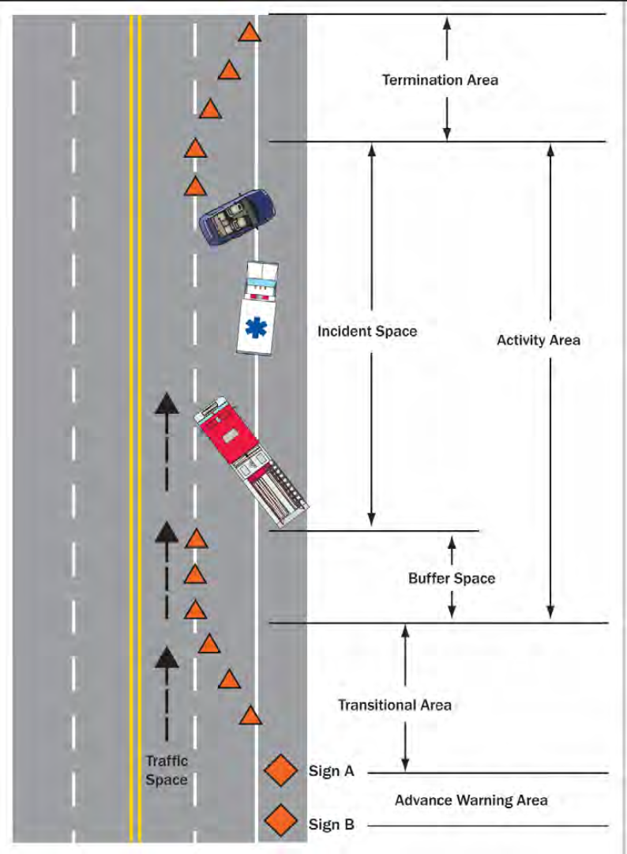

Appendix A2. – Illustration of proper positioning between shadow and blocker vehicles.
