**Fire & EMS Motor Vehicle Crash Response & Investigation Model Policy**

*This model program is intended for general information purposes only. It should not be construed as legal advice or legal opinion regarding any specific or factual situation. Always follow your organization’s policies and procedures as presented by your manager or supervisor.*

*This model policy uses the word ‘department’. If it is for a different type of agency (district, squad, or company), use the ‘Replace’ function to change ‘department’ to your type of agency.*

**Purpose**:

Insert name of agency establishes this policy to guide drivers, officers, and other stakeholders in the actions to be taken if a department vehicle is involved in any motor vehicle crash.

**Scope:**

This policy applies to all full-time, part-time, per-diem and volunteer firefighters and EMTs, and other persons who operate department vehicles. This policy applies whether the crash occurred on the road or at the station, such as backing, and for all events when a department vehicle strikes another vehicle, building, pedestrian, or other object, causing any noticeable damage to any vehicle, person, or object.

The depth and breadth of the investigation and report shall correspond to the severity of the crash. Minor crashes may only need a minor report. Crashes with significant damage, injuries, or liability exposures shall be more comprehensive and may require guidance from the department’s legal counsel.

**Definitions:**

*At-Fault Accident*: The department’s driver’s negligence, carelessness, or violation of a motor vehicle law directly caused the incident.

*Contributing Factors*: The conditions or actions that played a part in causing something to happen, although they may not be the sole or direct cause.

*Lagging Indicators*: A reactive measure that reflects past safety performance. It essentially shows how well (or poorly) a company has performed in preventing incidents and injuries after those events have already occurred, such as a year.

*Leading Indicactors*: Unlike lagging indicators (which reflect past performance), leading indicators focus on ongoing processes and behaviors that contribute to a safer workplace. They help organizations identify and address potential hazards before they result in accidents or injuries

*Preventable Accident*: The department’s driver failed to take reasonable actions to avoid the collision, even if not legally at fault or violating traffic laws.

*Root Cause Analysis*: A systematic process for identifying the fundamental reasons behind safety incidents or near misses, rather than just addressing the immediate symptoms. It is not about assigning blame to individuals. Instead, it focuses on identifying system flaws and process breakdowns that led to the incident.

*System Failure*: The inability of a system, or a component of a system, to perform its intended function, leading to a hazardous situation or a negative outcome. This can encompass a wide range of issues, including human error, ineffective or incomplete training, inadequate supervison, environmental conditions, or a combination of these.

*Unpreventable Accident*: The crash could not have been foreseen or prevented through the exercise of ordinary care by the department’s driver..

**Procedures:**

**Initial Response and Scene Management**

**Secure the Scene**: Ensure safety by controlling the area to prevent further harm and secondary crashes. If warning lights are not already activated, activate them now.

If firefighters are uninjured and not needed for patient care, put out cones or flares. Consider if a firefighter is best utilized as a flagger to warn oncoming traffic.

**Provide Immediate Assistance**: Call 9-1-1 and report the incident. No matter how minor, all crashes must have a police report taken. Offer first aid or medical care to affected individuals. Update the Dispatch on the condition of the injured parties.

**Make Needed Notifications**: If the vehicle was responding to an emergency incident, notify the Dispatch and Incident Command that you are unavailable.

Radio or call insert your department’s MVC reporting process in your agency.

**Document the scene and preserve evidence**: Take pictures, preferably with a department camera, but with a personal cell phone if needed. Take pictures at the first opportunity, as injuries and other priorities allow.

If there are no injuries and the vehicles are operable, consider moving both vehicles off the roadway to minimize the potential for secondary incidents.

**Complete Department Paperwork**: At the station, complete the insert name of form(s) the department uses to document MVCs. Attach a copy in the appendices. Consider including an instruction guide for filling out the form(s)

Collect photos, videos from traffic cameras or on-board apparatus dash cameras, diagrams, and written notes of the scene.

**Analysis and Root Cause Identification**

The department should have a process for either a standing MVC investigation team or an ad hoc MVC investigation team named by a lead official of the department. Committees often include representatives from chief officers, shift officers, drivers, and mechanics.

Within fourteen (14) days, the Motor Vehicle Crash Investigation Team shall:

**Records Review**: Analyze relevant documentation, including training records, maintenance logs, vehicle owner’s guide, and department policies and procedures**.**

Review witness statements. Meet with the witnesses, or conduct a walk-through, if clarification is needed.

**Analyze Findings**: Use collected data to identify patterns and potential contributing factors.

**Root Cause Analysis (RCA)**: Employ tools like the 5-Whys or Fishbone Analysis to trace the system or systems that resulted in the crash.

**Develop Potential Solutions**: Collaborate with employees and management to ensure the Investigation Team understands the circumstances of the incident and considers all potential contributing factors and system failures.

**Prepare the Report**: Complete and submit a report to insert the titles of those who should receive the report. The Report shall include following elements:

* Describe the actions of the department personnel before and after the incident,
* List the contributing factors and system failures findings that resulted in the crash
* Determine whether the crash was ‘At-fault’ or ‘Preventable’ or ‘Unpreventable’ on the part of the department’s driver.
* Propose a corrective action plan to address the system failure(s) that led to the crash. The corrective action plan should include a timeline for implementation. The corrective action plan should answer the question, ‘who will do what by when’.

**Corrective Actions & Monitoring**

**Implement Changes**: Introduce new procedures, training content, or equipment modifications.

**Evaluate Effectiveness**: Conduct periodic safety reviews to identify any recurring issues. Assess the success of implemented measures using leading and lagging indicators.

Appendix A - Insert Claims Administrator MVC Report Form

**Appendix B (optional) – Accident Investigation Report Template**

**Investigation Team:**

Include name, job title, home unit, and team role for each team member.

**Executive Summary:**

A brief narrative of the facts involving the accident including dates, locations, times, name of incident, jurisdiction(s), number of individuals involved, etc. Names of personnel involved in the accident are not to be included in this report (reference them by position).

**Narrative:**

Give a detailed chronological narrative including events leading up to and including the accident, as well as actions taken after the accident. This section will contain who, what, where and when.

**Investigation Process:**

Provide a brief narrative of actions taken by the investigation team. This narrative should include investigative actions and timeline. This section should also address if environmental, equipment, material, procedural, and human factors were present, and state how findings/recommendations were developed.

**Findings and Recommendations:**

List each finding, its discussion below it, and then the recommendation to address the finding.

* Findings are developed from the factual information. Each finding is a single event or condition. Each finding is an essential step in the accident sequence, but each finding is not necessarily causal or contributing. Findings must be substantiated by the factual data and listed in chronological order within the report. Do not include opinion or speculation.
* Discussion – Explain the factual and pertinent information that lead to the finding.
* Recommendations - Suggest the prevention measures that should be taken to prevent similar accidents. If no action is required, state as such. Do not include opinion or speculation.

**Observations and Conclusions:**

The Accident / Near Miss should be classified as one of three types:

***At Fault*** – The actions or inactions of the driver directly caused the accident / near miss.

***Preventable*** – The actions or inactions of the driver did not directly result in the accident / near miss, but there was a reasonable opportunity to for the driver to foresee the events that led to the accident / near miss and take action to avoid the incident.

***Not Preventable*** – The driver did not have a reasonable chance to foresee the events leading to the accident / near miss.

Investigation team’s opinions and inferences, and “lessons learned” should be captured in the section. The team should suggest an Action Plan to incorporate lessons learned into the operation, policies, procedures and training programs.

**Appendix # - The 5-Whys Analysis (optional)**

The "5 Whys" is a simple yet powerful root cause analysis technique that involves repeatedly asking "why" to drill down from an observed problem to its underlying cause.  By systematically exploring the chain of events that led to the problem, you can identify the root cause and develop more effective solutions. It moves the incident analysis from blaming an individual to identifying a system failure.

Here's how it works:

**1. Define the Problem:** Clearly state the problem you're trying to solve.

**2. Ask "Why?":** Ask why the problem occurred.  This initial question focuses on the immediate cause.

**3. Repeat the Process:** Continue asking "why" about the answer to each previous question.  Each answer becomes the basis for the next "why" question.

**4. Identify the Root Cause:** Typically, by the fifth "why," you'll have identified the root cause system failure.  Once the primary system failure is identified, you can develop solutions to address it.

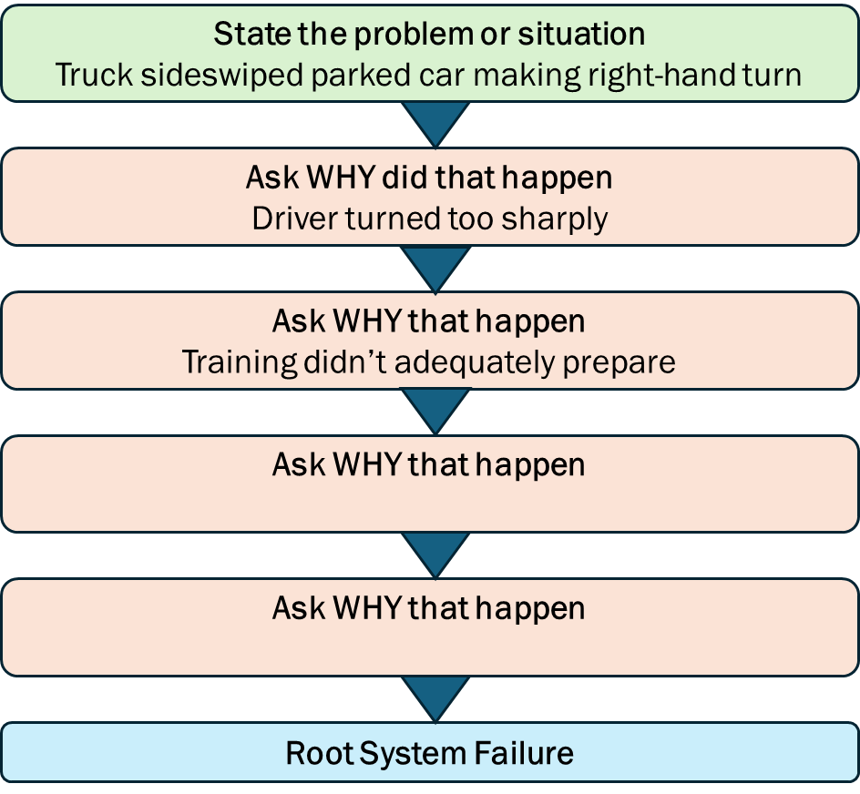

**Appendix # - Fishbone Analysis (optional)**

A fishbone diagram is a visual tool used to explore the potential causes of a specific problem or event. It helps teams brainstorm and categorize possible factors contributing to the problem, ultimately aiding in root cause analysis and problem-solving.

How it works:

**1. Problem Statement:** The problem to be analyzed is clearly defined and placed at the head of the fishbone diagram.

**2. Major Categories:** Potential major categories of causes are identified and represented as "bones" branching off the central "backbone" of the fish. Common categories include:

* + **Human factors:** hiring/selection process, fatigue, distraction, overload, stresses, age, experience,etc.
  + **Policies & procedures:** Processes, procedures, workflows.
  + **Supervisory factors:** oversight, instructions, feedback, favoritism, etc.
  + **Vehicle & equipment:** Cab layout, tools, technology.
  + **Training:** content, quality, timeliness, and effectiveness of initial, refresher, and continual training programs
  + **Environment:** External factors, such as night, rain, noise, street layout, etc.

**3. Root Causes:** Specific contributing factors within each category are identified and placed as branches off the corresponding "bone".

**4. Analysis:** The diagram allows for a structured brainstorming process, helping teams to visually analyze potential root causes and prioritize areas for further investigation or action.

