Off-Road Vehicle Model Policy
This model policy for fire and EMS agencies is intended for general information purposes only. It should not be construed as legal advice or legal opinion regarding any specific or factual situation. Always follow your organization’s policies and procedures as presented by your manager or supervisor.
This model policy uses the word department. If this policy is for a different type of agency (district, squad, or company), use the ‘Replace’ function to change.
Purpose:
Insert name of agency establishes this policy for the safe and effective use of UTVs (Utility Terrain Vehicles) and ATVs (All Terrain Vehicles) by personnel during operations. The aim is to ensure the safety of personnel, protect department property, and maintain operational effectiveness in all terrains.
Personnel using UTVs/ATVs for wildfire suppression, search and rescue, logistical support, and other approved activities must operate these vehicles responsibly, adhering to safety standards, vehicle manufacturer’s guidelines, local laws, and department regulations. This policy does not supersede manufactures recommendations or requirements. All manufactures requirements and recommendations must be followed for each vehicle.
Roles and Responsibilities:
WHO - insert name or title shall review this policy and updated as necessary to incorporate advances in technology, safety practices, and operational feedback.
Insert name or title of training officer shall review educational and training materials to incorporate advances in technology, safety practices, and operational feedback.
All personnel operating UVs and ATVs must exercise due diligence to minimize risks to themselves, their passengers, and the surrounding environment. Reckless or negligent operation will result in disciplinary action in accordance with department policy. All accidents, injuries, or near-misses must be reported immediately to WHO – insert name or title and documented per department policy.
Definitions:
All-Terrain Vehicle (ATV): a motorized off-road vehicle designed to travel on four low-pressure or non-pneumatic tires, having a seat designed to be straddled by the operator and handlebars for steering control.
Off-road: includes unpaved surfaces such as parks, woodlands, and beaches, and paved surfaces such as roads or parking lots when they are closed to normal vehicular traffic, such as floodwaters.
Utility terrain vehicle (UTV): is a four or more-wheeled off-road vehicle with a steering wheel, bench or bucket seating for side-by-side occupants, and often a truck-like bed for hauling cargo. The American National Standards Institute (ANSI) refers to UTVs as side-by-sides.
Utility Vehicle (UV): a vehicle, generally motorized, that is designed to carry out a specific task with more efficacy than a passenger vehicle.
Procedures:
Training for ATVs, UTVs, and UVs
Candidates to operate ATVs, UTVs, and UVs must:
- be at least 18 years of age
- have a valid driver’s license
- Operators of ATVs and UTVs shall complete the free online E-Course through the ATV Safety Institute (visit ATVsafety.org, or call 800-887-2887), review the Owner's Manual for the ATV
- have received appropriate safety and operating training, including a safety lecture, handling & maneuvering course, and light off-road/obstacle course. Candidates shall undergo a comprehensive knowledge and skill evaluation demonstrating competency prior to being authorized to operate without direct supervision by a qualified operator.
- be trained in utilizing ATVs, UTVs, and UVs in the department’s emergency response policies and procedures
- have the maturity level capable of operating ATVs, UTVs, or UVs in a working mindset, and not a recreational mindset
Operation of ATVs and UTVs
All operators and passengers must wear an approved helmet that meets or exceeds DOT and manufacturer's requirements while the vehicle is in operation. Structural and wildland helmets shall not be worn as head protection when operating or riding on an ATV or in a UTV. Additionally,
- All occupants must wear eye protection if the helmet is not equipped with a face shield.
- All occupants must have long pants & closed-toe footwear.
The personal protective equipment (PPE) for vehicle operation may not be the mission-required PPE. Mission-specific PPE may need to be carried and used separately.
When deploying ATVs or UTVs, responders should travel in pairs to ensure that if a problem occurs, someone is there to assist and/or call for help.
All safety equipment on the ATV or UTV must be used, including hard/soft doors, roll bars, tie-downs, compartment latches, wind screens, etc. ATVs and UTVs capable of towing trailers shall remain within the manufacturer’s load limits.
Operators must always maintain a reasonable speed, taking into account terrain, visibility, operational demands, and manufacturers' recommendations. Operators must slow to walking speed near other personnel, vehicles, or hazards, including smoke and low-light conditions. Speed limits off-road or while negotiating obstacles will be greatly reduced, and in accordance with the manufacturer’s recommendations to ensure the maximum possible safety.
ATV and UTV operators must assess the terrain and adapt driving techniques accordingly. Operators shall require personnel to dismount and assist in evaluating and negotiating obstacles, where possible, including steep terrain, crossing obstacles, fording water, backing up, and moving through large crowds. For wet or muddy conditions, evaluate traction and avoid deep mud or water unless deemed passable.
Operation of UVs
Seatbelts must be worn and securely fastened by all occupants of UVs at all times when the vehicle is in motion. UVs not equipped with seatbelts shall not be used for emergency purposes. Occupants shall not ride in positions that do not have a seatbelt or are not intended for passenger use, including, but not limited to, the rear cargo area, any bed skid modifications, the roof, the hood, or standing on running boards.
All safety equipment present on the UV must be utilized, including hard/soft doors, roll bars, equipment tie-downs, compartment latches, wind screens, etc. UVs with the ability to pull trailers shall stay within the manufacturer’s load limits.
Operators must always maintain a reasonable speed, taking into account terrain, visibility, operational demands, crowd conditions, and manufacturers' recommendations. Operators must slow to walking speed near other personnel, vehicles, or hazards, including smoke and low-light conditions. Speed limits off-road or while negotiating obstacles will be greatly reduced, and in accordance with the manufacturer’s recommendations to ensure the maximum possible safety.
UTs should only be operated on flat or nearly flat, even or nearly even surfaces due to their stability. Always operate within the conditions specified by the manufacturer’s guidelines.
Pre-Operation Checklist
Prior to deployment, the operator of the ATV, UTV, or UV shall be responsible for ensuring the vehicle is fully operational and safe.
- Inspect the vehicle for mechanical issues (e.g., brakes, tires, wheels, fluid levels, controls, cables, chain, chassis, winch, and lights).
- Ensure all safety equipment, including helmets, first aid kits, fire extinguishers, and communication devices, are on board.
- Load mission-critical equipment and supplies

Appendix A - ATV & UTV Driver Training Record
Driver Candidate: ___________________________________ Vehicle: ________________
□ Candidate has a valid New Jersey Driver’s License. Copy on file.
□ Candidate provided and reviewed the Owner's Manual

Riding Skills Station 1
Straight riding, braking, and serpentine around cones. (Basic skills)
Instructor evaluates students’ fit to the machine and ability to brake and maneuver around several obstacles on a flat level course. Students are to use hand signals at directional signs. No more than two machines on this course at a time (remind students of proper spacing).
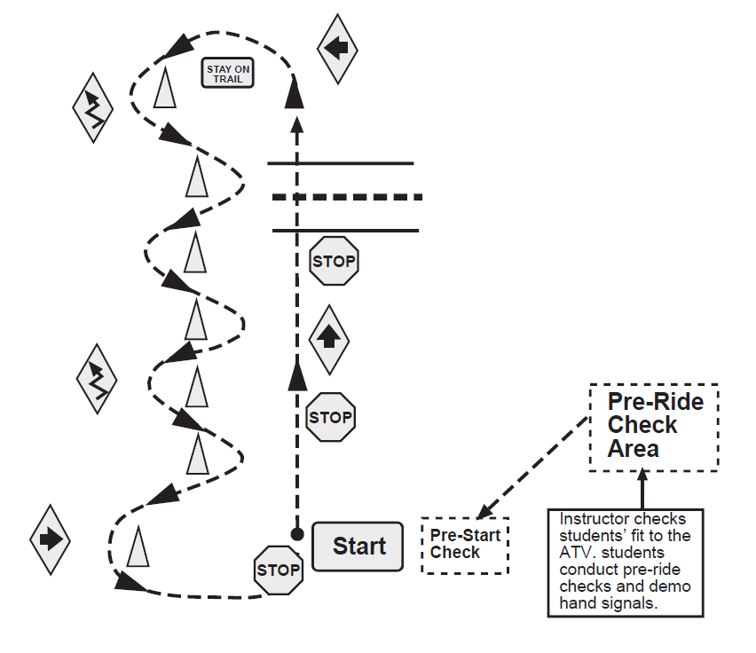

Successfully completed;
Instructor: ____________________________________ Date: __________________
Driver Candidate: ______________________________ Vehicle: ________________
Riding Skills Station 2
Students practice going over simulated logs at various angles. Some are from a stop, and one is done in reverse gear. No more than two ATVs on the course at a time (remind students to maintain proper spacing).
Students continue on the course until they can complete all obstacles with little difficulty.

Obstacle A – Medium 65x70 Prop - Students cross beams at a slow speed at a right angle.
Obstacle B – Large Offset Prop - Students cross beams at an angle.
Obstacle C – Small 4 x 4 Prop - Students stop once their front wheels are between beams, then slowly cross both beams.
Obstacle D – 48 x 60 V Prop - Students cross the beams at a slow speed, then stop and back across the beams, then go forward across again, and proceed to the start point.

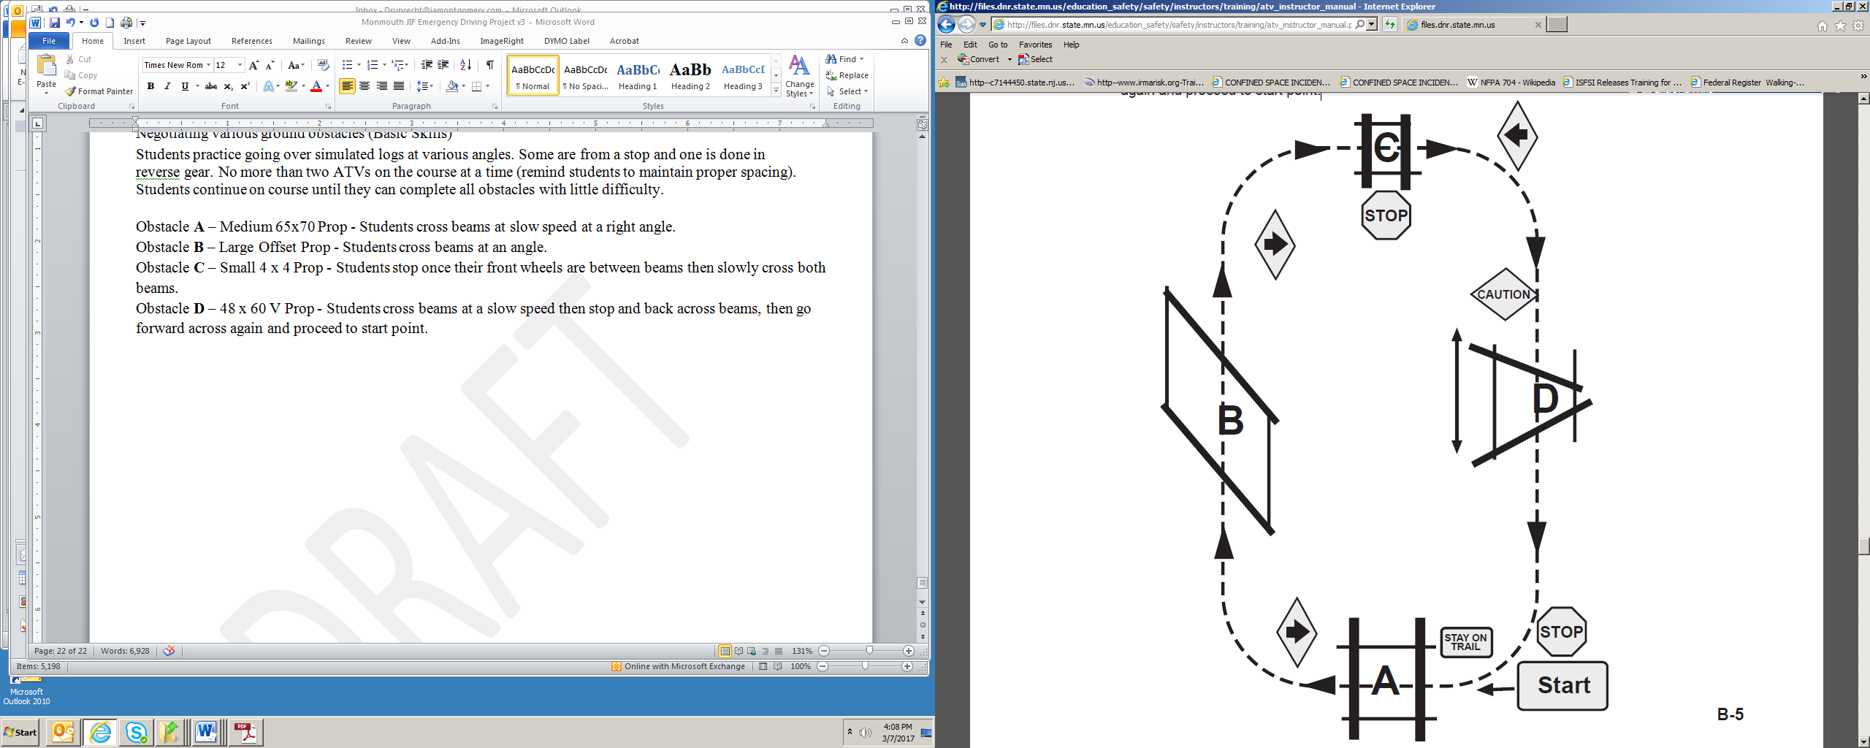

Successfully completed;
Instructor: ____________________________________ Date: __________________
Driver Candidate: ______________________________ Vehicle: ________________
Riding Skills Station 3

Students practice going uphill/downhill and side hilling. Students also practice tight circle turns and backing and turning, along with hand signals, and stopping and looking before crossing roads. No more than two ATVs on the course at a time.
Obstacle A – 4 Ramp System - Students follow a modified figure 8 going first up/downhill, side hilling then back over the hill, and then side hilling again.
Obstacle B – Students make three tight circle turns around a cone.
Obstacle C – Students stop and make a turn while backing up.

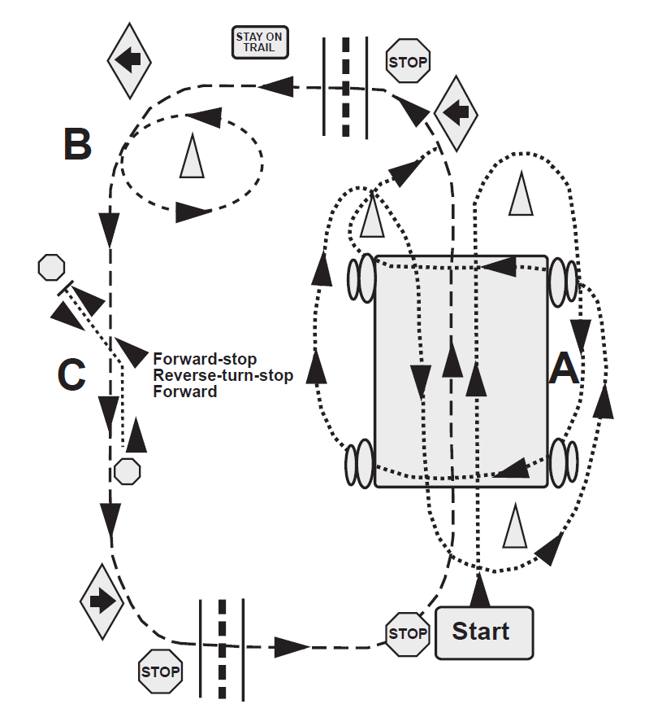

Successfully completed;
Instructor: ____________________________________ Date: __________________
Driver Candidate: ______________________________ Vehicle: ________________
Appendix B - Utility Vehicle Driver Training Record
Driver Candidate: ___________________________________ Vehicle: ________________
- Candidate has been provided and given an opportunity to review the Owner's Manual and the department’s Motor Vehicle Operation Policy.
- Candidate has a valid driver’s license and a satisfactory Motor Vehicle Record

Quiz:
T F Utility vehicles have a greater tendency to tip over than passenger vehicles.
T F Utility vehicles have the right-of-way when encountering pedestrians.
T F Utility vehicles are safe to operate on muddy surfaces.
T F Driver and passengers must be seated in designated seats and secured with a lap belt.
T F Utility carts may only be driven from the driver’s seat.
T F Arms and legs of driver and passengers must be kept inside the vehicle when in motion.
Demonstration of Skills:
Skill | Satisfactory (please initial) | Unsatisfactory – please explain
Candidate properly performed the pre-use inspection, using the agency pre-use checklist
Candidate entered vehicle with 3 points of contact and secured lap belt before starting vehicle
Candidate started vehicle, selected proper direction (forward or reverse), released brake, and proceeded in a straight line forward
Candidate performed 5 right turns and 5 left turns at intersections.
Candidate comes to smooth stops.
Candidate properly loaded and secured representative cargo.
Candidate parked vehicle in a safe location, applied parking brake, and turned off key. Exited the vehicle with 3 points of contact.
Additional Skills:
Successfully completed;
Instructor: ____________________________________ Date: __________________
Driver Candidate: ______________________________ Vehicle: ________________

