Vehicle Operation Model Template Policy
This model policy for fire and EMS agencies is intended for general information purposes only. It should not be construed as legal advice or legal opinion regarding any specific or factual situation. Always follow your organization’s policies and procedures as presented by your manager or supervisor.
This model policy uses the word department. If this policy is for a different type of agency (district, squad, or company), use the ‘Replace’ function to change.
Purpose:
Emergency vehicle response is a basic component for the success or failure of all other emergency functions. Without a safe response to the emergency scene, the Department cannot achieve its mission of saving lives and protecting property. drivers.
Insert name of agency establishes these emergency vehicle response best risk control guidelines to provide direction to leadership, vehicle operators, and driver trainers.
Roles and Responsibilities:
The Agency’s Chief Executive Officer shall be responsible for:
- Annual review of the policies, procedures, and practices of the content of this policy
- Review motor vehicle accidents or near-misses, or accident reports involving department apparatus, identify the contributing factors of the accident, and evaluate the system processes with the Department’s policies, procedures, and practices.
Department Driver Trainers, Instructors, and course designers shall be responsible for:
- Updating training and evaluation programs in response to
Officers or senior members in the front passenger seat shall be responsible for:
- Reinforce or enforce the policies, procedures, and practices of this policy during the operation of the department vehicle.
- Coach and debrief drivers after responses.
Apparatus operators/drivers shall operate department vehicles in accordance with this policy, with due regard for the safety of all parties, and always using their best judgment.
All personnel shall assist operators/drivers with the safe movement, backing, close-quarter maneuvering, and positioning. All riders in the vehicle shall be seated in a designated seat and wearing a seat belt, except when necessary for a critical task such as patient care.
References:
NFPA 1002 Standard for Fire Apparatus Driver/Operator Professional Qualifications
NFPA 1451 Standard for Training for a Fire and Emergency Service Vehicle Operations Training Program
NFPA 1500 Standard on Fire Department Occupational Safety, Health, and Wellness Program
NJ Title 39 Motor Vehicle Law
Procedures:
DRUG & ALCOHOL POLICY
The use of unlawful drugs and the abuse of alcohol or prescribed medications pose a threat to the health and safety of members. It shall be the policy of the department to adhere to a “ZERO TOLERANCE” level for being under the influence of drugs or alcohol of department drivers/operators, including medical cannabis.
A driver/operator who is observed by a department official to be possibly intoxicated or under the influence of alcohol or drugs shall be immediately tested and is subject to discipline as provided in the department’s Policy and Procedure Handbook.
A Model Employment Practices Policy and Procedure Manual is provided on the MEL website, www.njmel.org, under the Insurance and Claims menu.
All drivers of department and personal vehicles on department business must notify their supervisor within five (5) days of conviction for a drug or alcohol related violation, whether or not the violation occurred while performing a department function.
Drivers shall not operate any vehicle using prescription or over-the-counter medications that could affect their ability to operate motor vehicles or heavy equipment.
Any member driving a department vehicle, including a personal vehicle while on insert agency name business, that is involved in a motor vehicle accident that results in a vehicle being towed from the scene or an individual being transported by ambulance from the scene, shall immediately report the accident to WHO-insert name or title of the insert agency name . The department officer shall immediately make arrangements for the member to be tested for alcohol and drugs within 2 hours.
DEPARTMENT VEHICLES ASSIGNED TO INDIVIDUALS
Insert language on the use of chief officer vehicles assigned to a specific individual for their use during a term of office. Questions to consider include:
- Will the vehicle be permitted to be used within a specified distance, or only on Agency business
- Will the vehicle be permitted to used by other members of household
- How will the vehicle be transferred to other users such as newly-elected officers, or during leaves of absences
- Agencies should consult with their Risk Manager if the assigned vehicle is the only vehicle for the member’s household.
Department vehicles may be taken home only with the advance approval of WHO-insert name or title. When a member takes home a vehicle, it is to be used only for official business; any other use is not permitted. At no time shall children be in the vehicle when responding to an emergency.
All passengers shall wear a seat belt or be secured in a proper baby or toddler seat.
VEHICLE USE FOR NON-EMERGENCY ASSIGNMENTS
Anytime a department vehicle is out of the station on an assignment other than an emergency run, it shall be considered to be a routine operation. All routine operations will be considered non-emergency and shall be made using headlights only; no light bars, forward or rear-facing emergency lights, or sirens shall be used.
Unless a member receives permission from WHO-insert name or title, the department-owned vehicles shall be used only for official business.
VEHICLE EMERGENCY RESPONSE PROTOCOLS
Fire agencies should have a matrix of vehicle assignments based on the type of call initially indicated by dispatch.
Type of Dispatch | Order of Response
Report of fire or smoke showing | INSERT VEHICLE ASSIGNMENTS HERE
Fire & smoke alarm activation
Industrial water flow alarm
Carbon monoxide alarm
No life hazard indicated
Carbon monoxide alarm
Possible life hazard
Motor vehicle crash or fire
Motor vehicle crash with extrication
Industrial extrication
Hazardous material releases
Confined space rescue
Bomb threat & suspicious package
Active shooter & hostile event

The following responses shall be made in non-emergency mode (no emergency lights or sirens) unless there is a specific life hazard reason the officer directs otherwise:
- Carbon monoxide alarms with all occupants reported outside and asymptomatic
- Move up / cover assignments to neighboring fire stations
- Specify other types of dispatches
EMERGENCY VEHICLE OPERATIONS
Fire and EMS personnel have limited immunity from liability while responding to an emergency. However, that immunity is not absolute. Maintaining immunity requires that the driver of a vehicle responding to an emergency act with due diligence. DUE DILIGENCE is defined as appropriate carefulness, which is the degree of care that a prudent person would exercise. In most cases, this means the driver must obey the speed limit and other traffic laws. Responding to an emergency is not a license to speed or break traffic laws.
The use of warning lights and sirens is an affirmative decision on the part of the vehicle operator and shall be determined by Dispatch Protocols above and information available to the driver and officer on the vehicle. Audible and visual warning devices shall only be activated for True Emergencies. According to the U.S. Department of Transportation (DOT) Emergency Vehicle Operators Course Instructor's Manual, "a TRUE EMERGENCY is a situation in which there is a high probability of death or serious injury to an individual or significant property loss, and actions by an emergency vehicle operator may reduce the seriousness of the situation."
When responding to a true emergency, all visual warning devices will be operated. Audible warning devices should be operated as needed to alert and warn traffic and pedestrians of your approach.
Certain intersections are so congested, the department has implemented the following exceptions where warning lights and sirens will not be used and normal traffic patterns followed until safely through the intersection:
- Insert intersection and if there are time frames
Emergency vehicle drivers must understand that warning devices are not always effective in making other vehicle operators aware of your presence. Right-of-way can’t be forced or assumed; it must be given by the other driver(s). If not given, the emergency vehicle driver does not have the right of way.
a) Leaving the Station

While the crew is donning gear and entering the apparatus, the operator shall perform the 4-Step Start-up Procedure:
- Circle of Safety Inspection - circle the emergency vehicle for open cabinets and other obstacles.
- Adjustment of Cab Features - upon entering the cab, ensure that the driver’s seat is properly adjusted, mirrors are positioned, and controls are in the proper operating position.
- Wearing of Occupant Restraints - the emergency vehicle driver shall secure their seatbelt and must ensure that all crew members are properly wearing their seatbelts. The vehicle should not be moved unless all occupants are seated and properly belted.
- Receive Signal Before Moving - The emergency vehicle driver should receive a signal from either the officer or one of the crew members prior to moving the vehicle.
b) Response Operation Best Practices
Sterile Cab: The department encourages the sterile cab principles when the vehicle is in emergency and non-emergency modes. The principles include:
- Do not use cell phones even if a hands-free device is available (this includes calls and texts).
- The driver should not use onboard two-way communications or warning devices unless no other crew member is available to complete the task.
- Establish a system of critical communication. Some verbal commands that may be used include “clear right,” “clear left,” “prepare to stop,” and “vehicle not stopping.”
- Avoid non-essential personal communication between crew members during emergency response.
- Only a passenger and not the driver may use electronic reporting devices, GPS units, and mobile data terminals. Furthermore, passengers must limit their use during emergency response so they can help identify hazards.
- Maintain a cab that is free of objects placed on the dashboard and items of personnel kept in the vehicle. These items are distractions and can also become airborne during emergency maneuvers or accidents.
Use both hands on the steering wheel. Exceptions include operating another device on the vehicle, such as shifting or turning on the windshield wipers.
To reduce noise exposure to the crew, keep the windows up in your apparatus while responding, and wear a sound-attenuating headset(s).

Passenger Restraint: All persons driving or riding in fire department vehicles shall be seated in approved riding positions with seatbelts or safety restraints fastened when the vehicle is in motion.

Exception: A department member who is providing direct patient care inside an ambulance shall be permitted to release the seat belt momentarily while the vehicle is in motion if it is essential to provide patient care. Upon completion of the procedure, the member shall refasten the seatbelt. Time without the protection of a seat belt shall be minimized.

Speed: The driver shall never exceed a speed that is safe and prudent, based on road and weather conditions, other circumstances, and the vehicle's capabilities.
- Pick one:
a) The posted speed limit may be exceeded only when the required warning devices are in use and when weather, traffic, and road conditions are favorable.
b) The posted speed limit shall not be exceeded under any other conditions.
c) The maximum speed for a department vehicle, under favorable conditions, shall not exceed the posted speed limit by more than insert your department's maximum speed miles per hour.
- The posted advisory speed for a curve shall be considered the maximum allowable speed under all conditions, regardless of response condition.
Intersection Navigation Policy: Department vehicles shall follow the practices below when approaching and proceeding through intersections:
- Do not rely on warning lights and sirens to clear traffic. Begin to slow down as you approach the intersection and cover the brake. Scan the intersection and sidewalks for possible hazards.

- When approaching a traffic signal, be aware of “stale” green lights or yellow caution lights, begin to slow and prepare to stop as these will be turning red.

- The fire department emergency vehicle shall come to a full stop before entering a negative right-of-way intersection (red light, flashing red light, or stop sign), blind intersection, or any intersection where hazards are present and/or the driver cannot account for all oncoming traffic lanes. The emergency vehicle shall not enter the intersection until all approaching traffic has yielded the right-of-way and it is safe to proceed. The emergency vehicle driver shall ensure that all approaching vehicles in all lanes have yielded the right-of-way before advancing.

- If necessary, due to traffic conditions or visual obstructions, the emergency vehicle driver shall cross the intersection in stages, treating each lane as a separate intersection. The driver shall stop the vehicle, as necessary, to ensure that each lane may be crossed safely.

- When passing through an intersection where the emergency vehicle has the right-of-way, by virtue of a green light in the direction of travel and/or a stop signal (stop sign) for cross-traffic, the emergency vehicle shall not exceed the posted speed limit. Emergency vehicle drivers should not assume that oncoming/opposing traffic has stopped, even when facing a green signal or “clear” route; emergency vehicle drivers must visually confirm that oncoming/opposing traffic is stopped while approaching any intersection, and be prepared to stop immediately, if necessary.

Traffic Pre-Emption Policy: personnel must use the traffic pre-emption system on all dispatched emergency responses and when transporting critical patients to medical facilities. Use of the emitter system DOES NOT GUARANTEE or GRANT right-of-way.
Drivers must:
- Use traffic preemption devices when warning lights and or sirens are activated
- Turn off the traffic pre-emption emitter and warning devices when ordered to "reduce speed", or any order that means there is no longer an emergency
- Do not use the emitter during non-emergency functions, e.g., parades, community functions, store/food runs, etc.
- Attend training before operating a vehicle with an emitter
- Install the emitter device so that it will automatically turn off when transmission is in the park position, or when the vehicle parking or emergency brake is applied, the emitter is turned off automatically
The Department must ensure:
- Describe the department’s method for checking the system periodically to ensure it works
- All emitters must have on/off switch to allow the unit to be turned off when vehicle is in parade, for example
- Ensure that pre-emption equipped vehicles have parking brake or transmission automatic shutoffs
Traveling in Opposing Traffic Lanes: Operating emergency vehicles in opposing traffic lanes is extremely hazardous under all conditions and should only be considered under exceptional circumstances (i.e., if there is no alternate route of travel). When an emergency vehicle must travel in an opposing lane, the following practices shall be followed:
- When an emergency vehicle must travel in an opposing traffic lane, or in a center turn lane to maneuver around slow moving or stopped traffic, the emergency vehicle shall not exceed insert your departments maximum speed miles-per-hour, at a maximum. If there is a median separating the emergency vehicle from the slow or stopped traffic, the emergency vehicle shall not exceed a maximum of insert your departments maximum speed miles-per-hour.

- Actual speed should depend on the road, traffic, and weather conditions.)

- When approaching a controlled intersection (traffic lights or stop signs) in an opposing traffic lane or center turn lane, the emergency vehicle shall come to a full stop before entering the intersection, even if the traffic light is green in the direction of travel.

- When an emergency vehicle must travel against the traffic flow on a one-way street, it
shall be limited to short distances. Emergency vehicle drivers must proceed slowly and with extreme caution in these situations. The emergency vehicle must come to a full stop before entering an intersection while traveling in an opposing direction.
Passing Traffic in an Emergency Vehicle: When overtaking traffic that is moving in the same direction, the emergency vehicle driver shall give other drivers an opportunity to yield the right-of-way before passing. If it is necessary to pass a vehicle that has not yielded the right-of-way, the emergency vehicle shall provide as wide a clearance as possible.
- A fire department emergency vehicle shall not overtake another emergency vehicle that is traveling in the same direction unless the driver of the lead vehicle has indicated that the other may pass. A following vehicle may contact a leading vehicle by radio to request permission to pass.
Railroad Crossings: The emergency vehicle shall come to a full stop at unguarded railway grade crossings.
- Caution shall be exercised at grade crossings where warning lights and/or gates are provided.

- It is not always possible to hear an approaching train, due to the Doppler Effect and the type of locomotives used on some rail lines (particularly electric locomotives); otherwise, “normal” appearing highway vehicles, equipped with rail wheels, are also used by railroads and may be encountered at grade crossings.

- Warning devices and crossing gates are generally reliable, but can fail due to the harsh conditions to which they are exposed—these devices are designed to fail in the “safe” mode. When approaching a grade crossing with lowered gates and/or active lights and no apparent rail traffic, the emergency vehicle shall come to a full stop prior to the crossing; before proceeding, the emergency vehicle driver shall visually confirm that no train or other rail vehicle is approaching on the tracks. Complete confirmation may require that members physically dismount the vehicle to visually check the tracks.

Stopped School Bus: The emergency vehicle shall not pass a school bus that has stopped with red lights flashing to load or discharge passengers, unless the bus driver clearly signals that it is safe to pass.
- When clearly signaled by the bus driver that it is safe to pass a stopped school bus, the emergency vehicle shall proceed slowly and with extreme caution past the school bus; all members must be vigilant for children while approaching and passing the bus. The emergency vehicle driver must be prepared to stop immediately upon approaching, passing, and leaving the area where the school bus is stopped.
Operating in Adverse Weather or Road Conditions: Whenever conditions have caused reduced traction, such as water or snow on the road, the emergency vehicle driver shall.
- Reduce speed and steer, accelerate, or brake smoothly and evenly.
- Whenever conditions have limited vision, the emergency vehicle driver must reduce speed and steer, accelerate, or brake smoothly and evenly.
- Increase the following distance.

When operating on flooded streets, understand that many command vehicles, fire apparatus, and ambulances have significant electrical components, such as transmissions, engines, pumps, and more. Electrical boxes and components are often installed near the vehicle's frame. Unless there is a confirmed life hazard, vehicles should not traverse flood waters higher than insert the hubs of the tires or other level determined by the agency.
Flood waters, especially moving flood water, can erode the ground beneath roads. Be wary of unknown road conditions. Do not try to cross flooded roadways if you do not know the depth of the water. Be especially careful when passing under vehicle and railroad overpasses.
In extreme adverse conditions, such as a hurricane, vehicle movement will be in coordination with the emergency management’s command system.
Backing Policy: The following practices should be followed when moving vehicles in reverse. This includes at the station, at an emergency scene, and on non-emergency tasks.
- Before backing a fire department vehicle, the driver shall ensure that the intended path is clear of hazards or obstructions.

- One or more spotters shall be employed as guides in all situations where the driver does not have a clear vision of the path of travel. Two spotters should be assigned when backing large or heavy apparatus–one covering each side of the vehicle. When available, a third spotter can monitor traffic or, especially with aerial apparatus, watch the front of the vehicle for overhead obstructions.

- A spotter is responsible for guiding the driver and ensuring that any potential hazards are avoided. Standard signals shall be used to communicate with the driver during the backing maneuver; hand or voice signals transmitted over a portable radio may be used for this purpose. Standard hand signals for spotters are given in Appendix insert #.

- The spotter(s) shall be on the ground, to the rear of the vehicle, and shall remain visible to the driver at all times. If the driver loses sight of the spotter(s) at any time, the driver shall immediately stop the vehicle.

- If it is essential to back a vehicle with limited rearward visibility and no spotter is available, the driver shall stop, dismount, and visually perform a 360-degree check around the vehicle before backing, with emphasis on the area behind and to both sides. After checking the area, the driver shall back the vehicle at a slow speed and with extreme caution, prepared to stop immediately if necessary.

Maneuvering at Incidents: Drivers shall exercise extreme caution while maneuvering emergency vehicles at an incident scene; other drivers and pedestrians may be distracted or preoccupied by events and a variety of hazards (e.g., downed or low-hanging wires, limited visibility, hazardous materials, etc.) may be encountered. Vehicles shall be moved slowly and cautiously, with spotters assigned to guide the driver in tight situations.
- When streets have been closed to regular traffic, the emergency vehicle driver remains fully responsible for the safe and prudent operation of the vehicle at all times.

- When operating at an incident scene where the streets have not been closed to regular traffic, fire department vehicles shall be positioned, parked, or staged in a manner that considers safety as a primary factor.

- Before moving an emergency vehicle in any location, the driver shall ensure that all occupants are seated and properly secured in approved riding positions. The driver shall also ensure that no one is in the process of mounting, dismounting, standing on top of, or on the outside of, the vehicle.

- Under no circumstances shall members be allowed to ride on the outside of a moving apparatus, including the tailboard, roof, aerial platform/bucket, or a top-mounted pump panel.

c) Returning to Station
The trip back to the station shall be made in non-emergency mode using no warning lights or siren. Obey all traffic laws and traffic control devices, in compliance with New Jersey motor vehicle laws for civilian traffic.
d) Vehicle Security
The use of emergency vehicles by individuals with malicious motives, such as terrorism or gaining access to restricted areas, is a recognized risk for emergency agencies. Drivers and members shall take the following actions to prevent the unauthorized use or theft of vehicles and equipment on the vehicles when not on an emergency scene.
- Leave a crew member with the vehicle when idling.
- When possible, shut off the engine and remove the ignition key from any vehicle left unattended. Lock vehicles, equipment, and exterior storage compartments whenever practical.
- Secure vehicles when in the station. Leave bay doors down. Lock station entrances. Remove items utilized to prop open doors

Hand Signals for Spotters (Fire Department version) (choose one picture for each signal – delete other pictures)

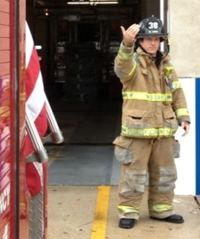It is safe to proceed backwards

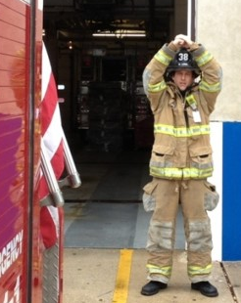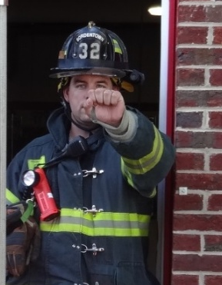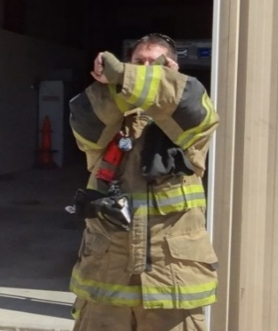
Stop the vehicle

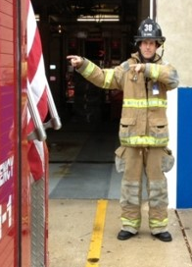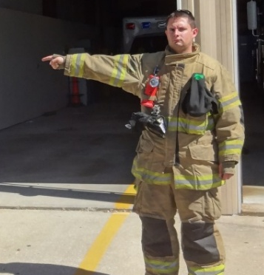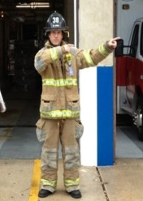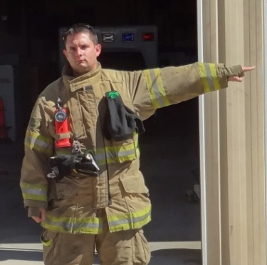
Move vehicle to the right Move vehicle to the left

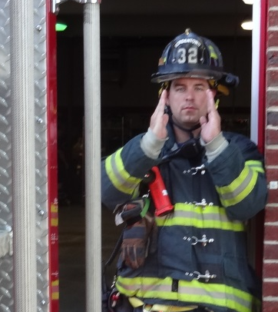
Go slow. You’re close to an obstruction.

